AGENDA
Fish Passage Operation and Maintenance (FPOM) Team meeting
August 11, 2011 (0900-1400)
St. Helens Room- NOAA Fisheries 10th Floor
Conference line: 888-675-2535 FPOM code: 4849586

- Review Agenda and approve July minutes. (Klatte)

- Action Items
  - NWP Action Items

  - NWW Action Items
    - [Dec 10] MCN emergency bypass operations. ACTION: NWW engineers will send drawings to Dykstra, who will then send them to FPOM. Information will include depths and velocities, etc. STATUS:
    - [May 11] LMN RSW SOP. ACTION: NWW will provide SOP at August FPOM.
    - [May 11] LGS T-1 Transformer Iso-Phase Bus Seal Repairs & T-1/T-2 500 KV Disconnects Inspection. ACTION: Stephenson will investigate the potential for an emergency fishing closure during this work.
    - [Jun 11] MCN count station debris on the picket leads. ACTION: NWW will confirm if there is a hole in the upstream lead and if there isn’t, the upstream leads will be left out of the water all the time.
    - [Jun 11] LGS adult passage. ACTION: Moody and Dykstra will bring this issue to the SRWG forum. They will develop a draft one-pager, in conjunction with FPOM members.
    - [Jun 11] MCN TSW removal. ACTION: Dykstra will provide Fredricks with times when the spill pattern was altered.
    - [Jun 11] Spill weir debris clogs. ACTION: NWW will draft language to allow for immediate spills when debris builds up in front of surface routes.
    - [Jun 11] MCN unused fishway entrances. ACTION: NWW will bring back a schedule detailing how much time it would take to fill the openings with concrete.

- Updates
  - NWW Updates (Moody)
    - NWW Turbine cooling water strainer update. The spreadsheet will be posted to the website. http://www.nwd-wc.usace.army.mil/tmt/documents/FPOM/2010/.
    - Transportation.
      - Every other day trucking mode- 17 August.
      - MCN daily transport since 3 August.

  - NWP Updates
    - Mid-season fishway ROV inspection results.
      - BON- displaced grates in the Washington Shore fishway.
      - TDA
      - JDA
    - JDA count station pickets- trapped adult update.

  - Researcher updates.
    - PNNL collecting lamprey from JDA SMF.
    - Bass fishing at TDA. A few highlights: ODFW has rounded the 1,000 fish mark. The weekly catch (averaging 100-150 per week) now consists of approximately 10% recaptures, and it’s rumored that the pikeminnow angling team is seeing a fair number of PIT-tagged bass at this stage as well. Additionally, powerhouse catches (both sides) remain strong, whereas those in riprap areas have trailed off considerably in the recent few weeks.
    - BON AFF. Interpretation of the AFF use temperature limitations in the FPP (does WDFW's study fall under the US v Oregon exception).

  - FFDRWG Updates.
  - RCC update.
  - BPA updates.

- Coordination/Notification forms needing approval.
  - LMN Switchgear replacement.

- Critical Infrastructure. (Fredricks)

- NWP DSM orifices.
  - JDA new LED orifice lights. (Zyndol)
  - JDA orifice gate/shaft issues. (Fredricks, Zyndol)
  - BON orifice gate/shaft issues. Hausmann reported BON fabricated and installed more robust connections on all DSM2 orifice gates. BON no longer has concerns regarding metal fatigue with the orifice gates.

- Fish count website. (Stansell, Dalen) Would like the agencies to comment on a change to the look and query features of the website, specifically, the separation of salmonids from lamprey (and shad). The reports page is getting too big, especially with all the LPS and night lamprey counts soon to be coming. Every feature will remain the same as it is now, just with lamprey having their own database site. The column headings are still up for discussion, but there will likely be one more than is show on the attached sample…that being “total lamprey”, adding all others together.
  - The lamprey LPS counts that were posted for awhile may change as we have a meeting w/NMFS and COE folks later this month to discuss LPS counting protocols, proofing, etc.

- BON juvenile lamprey mortality. (Fredricks)

- TDA fishlock testing. (Cordie) As part of the east fishladder backup study, we're looking into cleaning some piping in the fishlock which may flush some mud into the culdesac. Our project engineer is working on plans now.

- LGS SW operations. (Moody)

- LWG Powerhouse operations (Moody)
  - Adult Fish Trap Operations for Fall 2011

- DWR draft tube salvage. (Moody)

- Task Group Updates.
  - FFU Avian observations. (Zorich)
  - AFF mods (Mackey). CRITFC will provide information about what mods they would like to see. A future meeting will be scheduled with TAC and other policy folks. Mackey reported the grating and supports are in need of replacement sooner rather than later. The tank is going forward. Mods to the brail pool to keep the fish from getting under have been completed. PIT tag detection on the brail pool exit has not moved forward. The task group will meet after the August FPOM.
    - This meeting is to discuss CRITFCs proposed modifications and an update on the anesthetic tank and flume mods.
  - Sturgeon task group (Hausmann). Currently investigating tanks for salvage. Lorz requested the task group meet after the September FPOM.

- 2012 FPP Change Forms.
  - 12AppG001 BON AFF fish over 100cm.

- Potential 2012 FPP change forms.
  - BON ITS gate settings for kelts.
  - LMN spill pattern. (effort led by Hevlin and NWW)
  - Updated acronyms from NWW and NWP. (specifically referring to TSWs, RSWs, SWs, etc)
  - NWP crowder setting. This will be universal language for all three projects. (effort led by Cordie)
  - BON Fish screen re-installation criteria. May need to include turbidity, flows, phase of the moon, star alignment, and debris found on other racks.

- Other

- Break.

- AFF Task Group meeting.

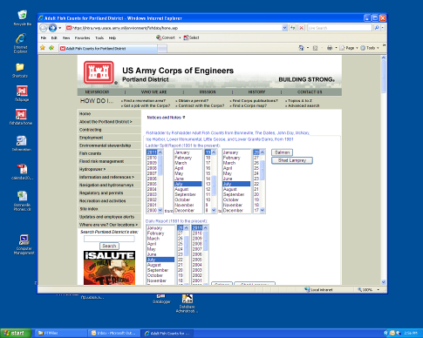

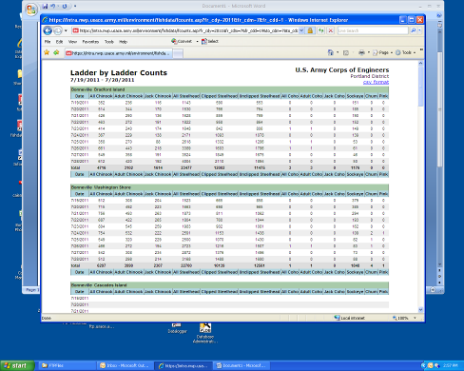
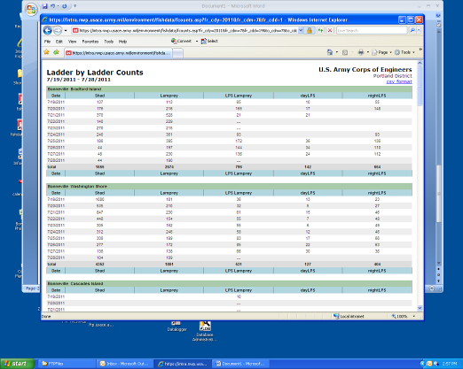

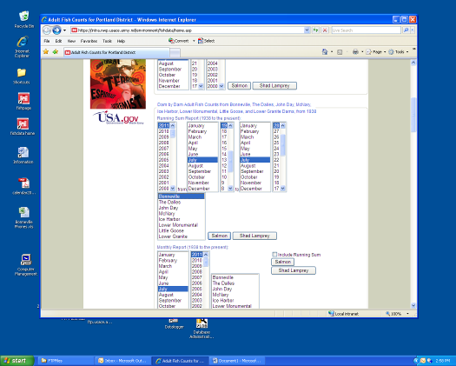
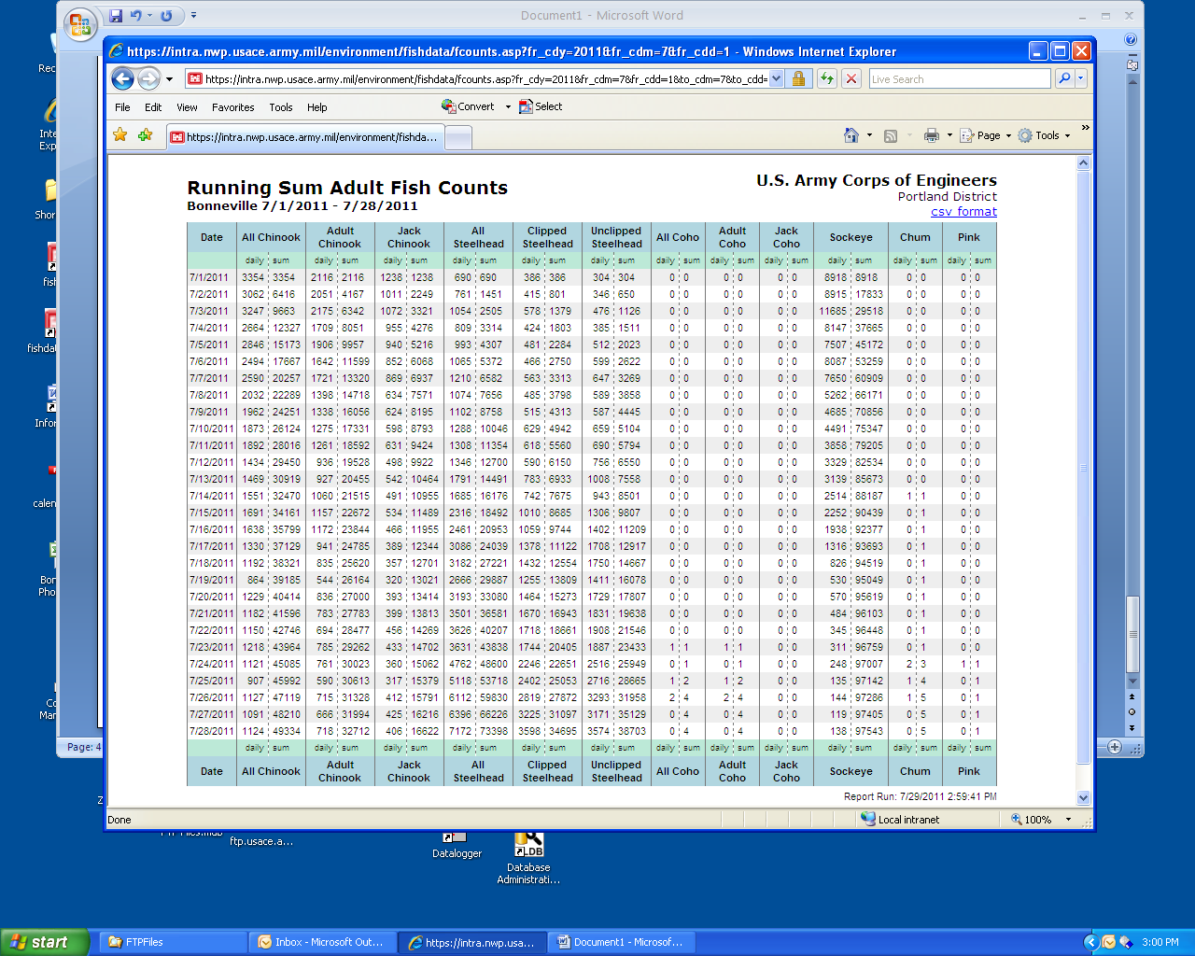

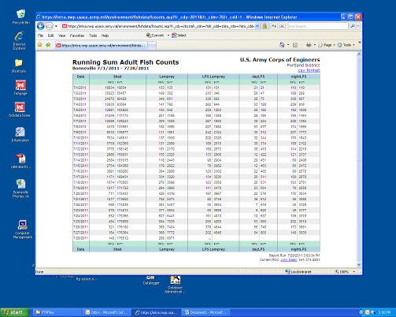
OFFICIAL COORDINATION REQUEST FOR
NON-ROUTINE OPERATIONS AND MAINTENANCE
☺☺☺☺☺☺☺☺☺☺☺☺☺☺☺☺☺☺☺☺☺☺☺☺☺☺☺☺☺☺☺☺☺☺☺☺☺☺
COORDINATION DATE- Aug 2, 2011
PROJECT- Lower Monumental
RESPONSE DATE- FPOM meeting August 11, 2011
Description of the problem: UPDATE TO JUNE FPOM MEETING.
At the time the FPP was in draft, it was thought this work would not need this level of outage necessary for this work. Since the contracts have been awarded and specific discussions of the work have evolved to a point to determine that we will need this level of outage to complete the work. On June 9, we received FPOM approval for the outages to install and remove the temporary power for the SQ2 portion of this job.

It was recently discovered that Main Units 5 &6 will be out of service while the SQ2 is being replaced. The contractor is providing temporary power at SU5 & SU6 for this job, as specified at 480v 3 phase. The SQ2 also has a 4160v 3 phase power that will not have temporary power. The 4160v power services CP5 & CP6 with provides power to the Governor oil pumps of Main Units 5 &6

Type of outage required: Emergency Diesel / SQ2 installation contract (LSR Diesel Generator and Switchgear Replacement Projects); the contract work for on the SQ2 portion of this job will require two power house outages. The first outage will be necessary to install temporary power to keep critical systems online while the SQ2 is being replaced. The second outage will be necessary to remove the temporary power and cut over to the new SQ2 panel. The CO2 fire suppression is fed out of SQ2 and generation is not permitted unless the CO2 system is active. The placeholders for this work are in November of 2011. These outages will be all 6 units off line and back feeding the power house via BPA feed.

In addition to the power house outages for temporary power installation and removal, the facility will also need Units 5 &6 OOS while the SQ2 is being replaced.

Impact on facility operation: The tentative date for cutover to temporary power is November 15 for ½ day to 1 day. The tentative date for reinstatement of permanent power 30 November for a ½ day to 1 day. All 6 units OOS for this time We will power the Lower Monumental facility via the 500KV line and backfeeding the power the house from the grid

Unit 5 & 6 will be OOS for the two week duration between the power house outage dates, while SQ2 is oos.

Length of time for repairs: November 7 to November 30

Expected impacts on fish passage: Adult fish counting ends October 31 as all runs have largely passed by this time. Fish pumps and equipment will operate as normal for maintenance of fish ladder passage conditions. The river flow will be spilled while the units are off line so adult fish attraction flow will change and favor the south ladder.
Overall there is a possibility of minor delay as adult fish follow attraction flow (spill) to the south entrance, but overall impact is likely to be negligible. All entrances, north ladder and south ladder, will be operated normally thus providing passage opportunity at north, mid, and south river.

The juvenile fish bypass is operated October 1 through December 15 for adult fallback. Juvenile fish numbers in November will be largely composed of shad juveniles with extremely few salmonids in the mix. In that the vast majority of the river flow during the outage will be spill, any juvenile outmigrants will pass via this route. Under normal November low flow conditions, gas levels will not likely exceed the 120% gas cap.

Current data on fish passage is unavailable for the period of November through March and historic data for this period is unlikely to accurately represent current passage numbers.
Comments from agencies
On June 9, we received FPOM approval for the outages to install and remove the temporary power for the SQ2 portion of this job.
Final results:
☺☺☺☺☺☺☺☺☺☺☺☺☺☺☺☺☺☺☺☺☺☺☺☺☺☺☺☺☺☺☺☺☺☺☺☺☺☺
☺☺☺☺☺☺☺☺☺☺☺☺☺☺☺☺☺☺☺☺☺☺☺☺☺☺☺☺☺☺☺☺☺☺☺☺☺☺
FPP Change Forms
☻☻☻☻☻☻☻☻☻☻☻☻☻☻☻☻☻☻☻☻☻☻☻☻☻☻☻☻☻☻☻☻☻☻☻☻☻
☻☻☻☻☻☻☻☻☻☻☻☻☻☻☻☻☻☻☻☻☻☻☻☻☻☻☻☻☻☻☻☻☻☻☻☻☻
Change Request Number: 12AppG001BON
Date: August 5, 2011
Proposed by: CRITFC
Location of Change- 11AppG_ BON 1.13
Current Language:

- General facility protocols General facility protocols.
1.13. Fish greater than 100 cm in length will not be diverted into the anesthetic tank. These fish will be allowed to return to the ladder untouched.

Proposed Change: Remove 1.13 completely
Reason for Change: CRITFC has installed a new sampling tank that is 6 inches wider and 6 inches longer. FPOM had agreed that this sampling restriction could be removed once a new sampling tank was installed.
Comments from others:
Record of Final Action:
☻☻☻☻☻☻☻☻☻☻☻☻☻☻☻☻☻☻☻☻☻☻☻☻☻☻☻☻☻☻☻☻☻☻☻☻☻
☻☻☻☻☻☻☻☻☻☻☻☻☻☻☻☻☻☻☻☻☻☻☻☻☻☻☻☻☻☻☻☻☻☻☻☻☻

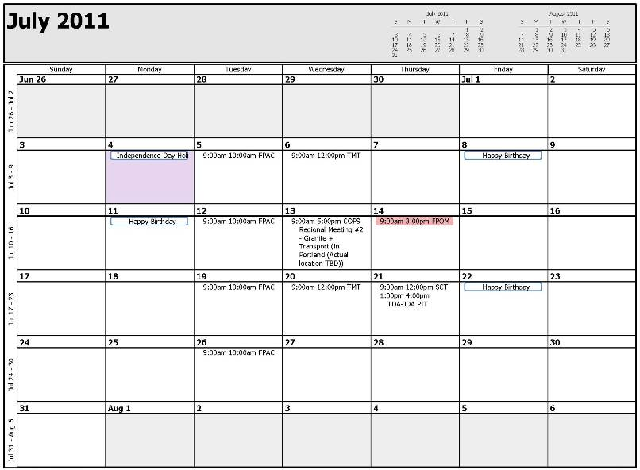
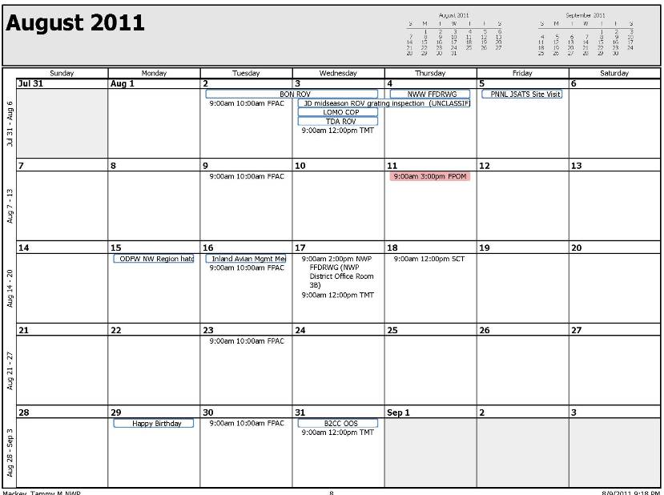
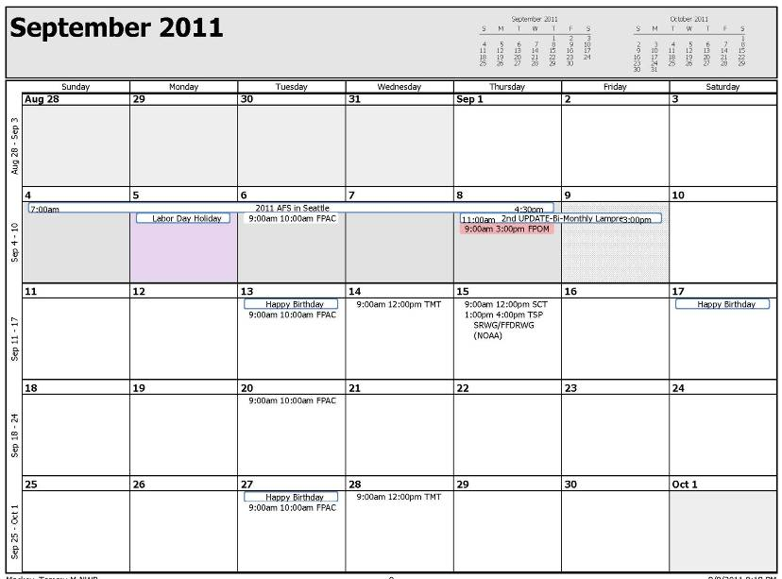
MEMORANDUM

FROM: John Whiteaker
Fishery Scientist
CRITFC

SUBJECT: Adult Fish Facility at Bonneville Dam

The Columbia River Inter-Tribal Fish Commission has been sampling adult salmonids at the Bonneville Dam Adult Fish Facility (AFF) since 1985. The primary focus of this research is to provide age, length at age, and stock composition information for Pacific salmon and steelhead to regional managers for assessing adult returns above Bonneville Dam. This information is critical for monitoring ocean abundance, in-season harvest, run reconstruction, forecasting, and stock specific escapement. Data collected are predominantly used by the Pacific Salmon Commission’s (PSC) United States Chinook Technical Committee (USCTC) and the U.S. v. Oregon’s Technical Advisory Committee (TAC) for the region’s salmon management. Base funding for this project comes from the PSC and the Columbia River Accords.

For several years the use and operation of the AFF has become increasingly restrictive making it difficult, if not impossible, to achieve all our monitoring goals. Key concerns from the Fish Passage Operations and Maintenance (FPOM) group have included the amount of time the picket leads divert fish from the Washington shore fish ladder through the AFF, the number of fish diverted through the facility, the added elevation and migration time, and sampling at water temperatures above 70 degrees Fahrenheit. While these concerns are valid, the reduced sampling capability is of equal concern to CRITFC and the technical committees that use the data. Since CRITFC will likely be involved in this base monitoring for many years onto the future, a solution needs to be found to satisfy both the needs and concerns of the Pacific salmon managers.

While loosening the sampling restrictions at the AFF would be of minimum cost, it has become apparent that FPOM will not buy into this option. The alternative would be to modify the existing facility to increase our sampling capabilities, or build an entirely new adult fish facility. From a sampling perspective, the primary factor affecting sample size is the four hour time restriction allowed to divert fish into the AFF. This is enough time to send a suitable number of fish through the facility but the pass-through configuration doesn’t allow us to sample the majority of fish migrating through the lab. For example on August 5, 2011 the picket leads were dropped at 08:48 and raised at 12:48. There were a total of 3279 steelhead that passed the Washington shore count station for the day, 234 were counted passing through flumes in the AFF, and a total of 52 steelhead were sampled. In the time it takes to anesthetize, sample and tag the fish (along with water changes), we missed 77.8% of the fish passing through the facility. A trap and hold configuration would be far more efficient for sampling and could reduce the total time and number of fish that would have to go through the lab. On August 5th, 100 steelhead passed through the flumes in the first 2 hours. With a trap and hold capability, there would have been no need to continue trapping for the day.

CRITFC researchers would prefer a trap and hold configuration with a capacity for 200-300 adults. This would allow us to attain adequate sample sizes for all species while minimizing the number of fish that are diverted through the facility. Adapting the existing AFF to a trap and hold configuration would be difficult due to its small usable footprint and limited elevation between the collection pool and return fish-way, but it’s not impossible (Figure 1). The other issue with adapting the existing configuration of the AFF is the added migration, elevation and sheer volume of the entrance fish ladder and collection pool but this too may be remedied by the construction of an alternate route into the facility (Figure 2). The only other option would be the construction of a new sampling facility.

The ideal adult sampling facility would be at a similar elevation to the main fish ladder, have a minimal migration distance to a trap, a collection pool holding capacity of 300 fish, a sampling area with multiple stations, an adequate recovery pool with volitional release, and reasonable return (elevation, distance) to the main fish ladder (Figure 3). A new facility could also add improvements such as chillers to address sampling at higher water temperatures and an automated trap to collect fish randomly. While a trap and hold facility may increase the impact of individual fish that are sampled, it would drastically reduce the overall impact to migrating salmon by minimizing the number of fish going through the facility over the current configuration. With modifications or construction of a new facility, there is no reason that FPOM concerns cannot be remedied.

Of course whenever discussions of building new facilities or retrofits of old facilities come up, the immediate response comes down to “who is going to pay for it”. This too is not an impassable problem that can’t be addressed and should not be used as an excuse to impede progress towards a reasonable resolution. Fish Accords partners have a vested interest in working together on these types of problems.

Crowder/Lift

Fish Ladder
Holding tank
Up to 300 fish
Anesthetic/ Sampling stations
Recovery
Pool
Sort Station

